**Task one**

**Graph representation**

To store this graph, we use an **adjacency matrix**, a 2D array where each entry (i, j) represents the distance between city i and city j. Since this graph is **bidirectional**, the adjacency matrix is **symmetric**, meaning matrix[i][j] = matrix[j][i].

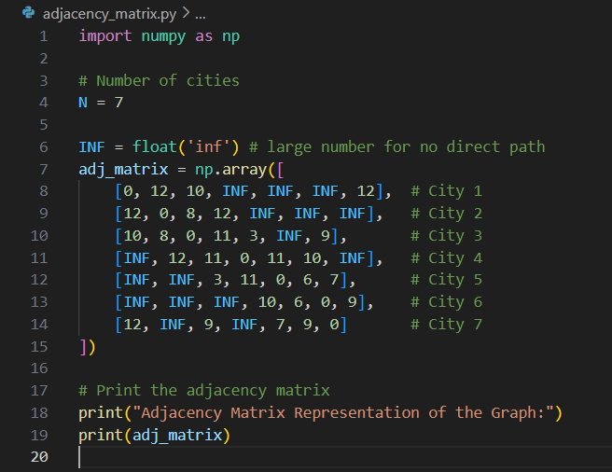

**Why Use an Adjacency Matrix?**

An adjacency matrix is preferred because it provides constant-time **(O(1))** lookups for edge distances, making it efficient for algorithms that require frequent distance checks (like Dynamic Programming-based TSP). While it uses **O(N²)** memory, which can be large for sparse graphs, it is manageable for small-scale problems like this 7-city TSP.